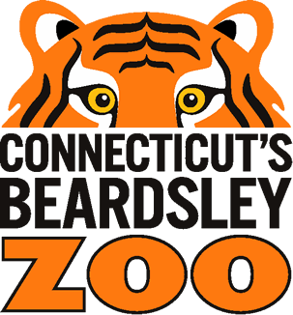
Scout Wild Assembly Date Request Form Connecticut’s Beardsley Zoo Education Department
1875 Noble Avenue
Bridgeport, CT 06610-1600

Please return this form to the Zoo’s Education Department to request your Wild Assembly
You should receive an invoice / confirmation within 2 weeks

Phone (203) 394-6563 www.beardsleyzoo.org

Email request to: programming@beardsleyzoo.org

Life in the Wild:
Students learn about the amazing adaptations animals have for thriving in their habitats via the Zoo’s animal ambassadors and artifacts. This informative, entertaining program will inspire and delight your students and faculty.

Name of Facility |  | Facility Description (Public School, Assisted Living)
Street Address |  | City |  |  | State and Zip Code
Contact Name and Title Contact |  |  | E-mail Address
Facility Phone Number | Facility Fax Number |  |  | Alternate Cell or Home Phone

Facility details Room accessibility
*Parking location |  | Entrance location | Elevator? | Ramp? | Stairs?
Program room description (auditorium, lunch room, gym) |  |  | Heated? | Air conditioned?
Grade / Age of students | Number of students |  | Number of adults
Program date (1st choice) | Program date (2nd choice) |  | Program Time(s)
*For animals’ health and safety please reserve a parking space near entrance for Zoo vehicle
Fees: One hour program; $350 for up to 300 people $450 for 400 people $550 for 500 people

Mileage Fee: $30 outside15-mile driving distance, $50 for outside 35-miles, $75 outside 55-miles

Check here if you would like to honorarily adopt an animal for your classroom, school, or location. Adoption boxes start at $75 and we will provide you with a list of available animals to choose from upon receiving this form with this box marked.

Payment Method: Check Box

Credit/Debit | Check | Other (Write in)

